**Explanation of Week four**

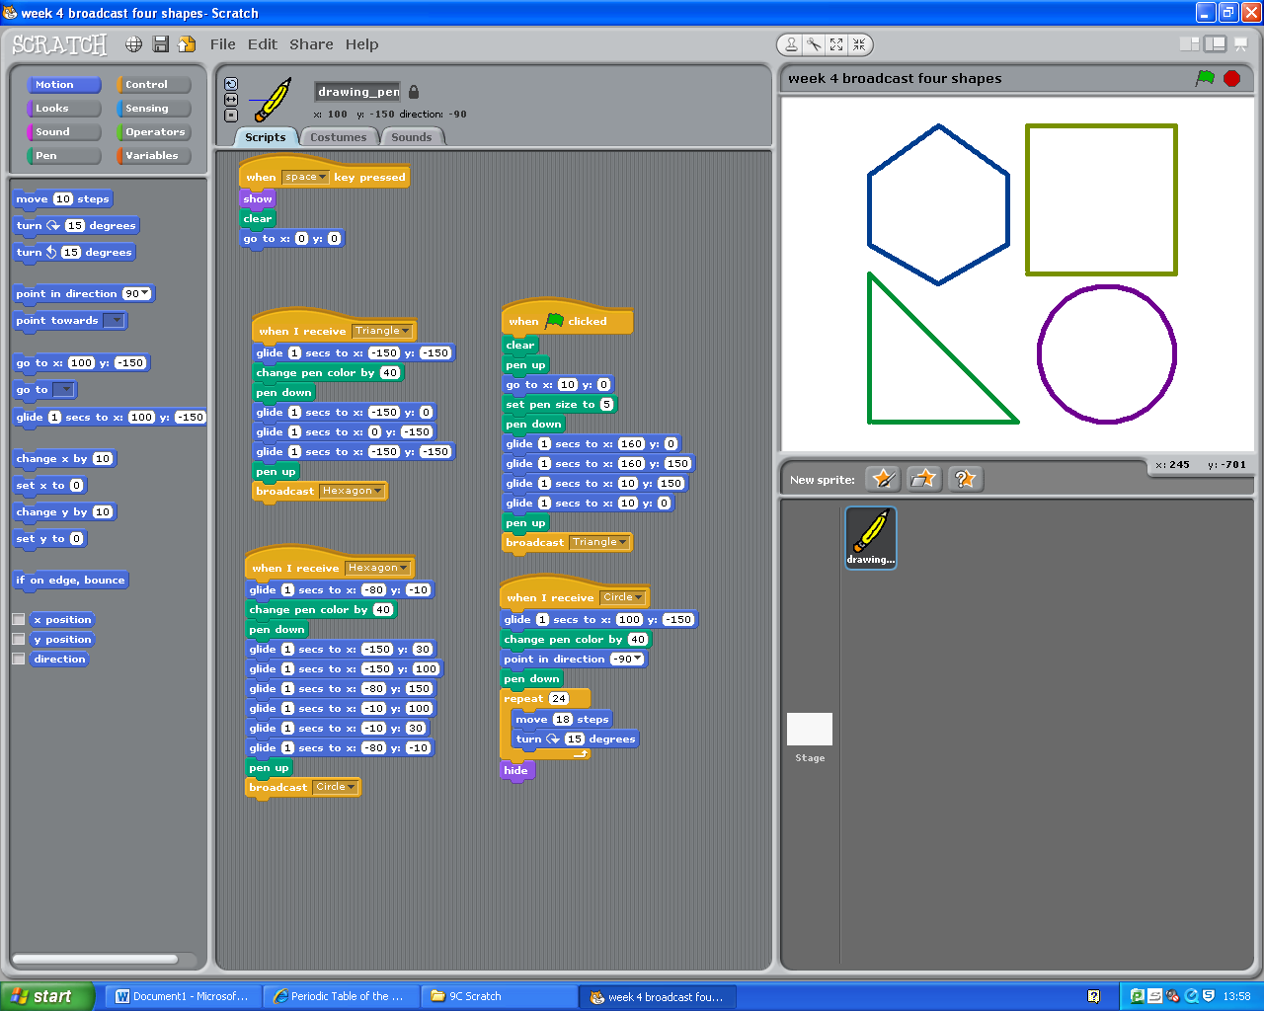Today in my lesson I used advanced scripting to make a pen draw four shapes without a human drawing it. This is a form of computer control. I had to use the glide script and the pen up and pen down. The pen up script make the pen stop writing and the pen down script make the pen write/ draw. I used this when drawing four shapes I used the pen down when I wanted to draw a shape and I used a pen up script when I wanted to move the pen to a different location so I can draw another shape. Because the script was so long (28 lines in total) I had to use the broadcast script to break it down so that the script would be much shorter. Looks like the below

Now that I have my pen draw four shapes without anyone doing anything I needed to clear the screen and re-centre the pen so I can start again when I run the script again.

In my cops and robbers project I am going to use the broadcast script to send out a broadcast so that if the copper takes the diamond music will play, the background will change and the cop would speed up.